**IDEA B SharePoint Edit Form Solutions (Draft)**

1. Overview:

a. Description:

b. Location: [IDEA B Application (sharepoint.com)](https://nmgov.sharepoint.com/sites/IDEABGrant/SitePages/Home.aspx)

2. Solution Components:

a. Custom Reusable SharePoint Online Modern Site Page

b. Out of the Box Web Parts

c. SPFx Reusable Web Parts

d. Custom Nintex Forms

e. Custom Reusable JSON Formatting

3. SharePoint Online Modern Site Page:

a. Page Security – TBD

b. Target Audiences – TBD

c. Section Types:

i. One Column Section – One Column sections are used to accommodate the list view web parts that have more fields being displayed in them.

ii. Two Column Section – Two Column sections are used to accommodate the list view web parts that have less fields being displayed in them.

iii. Collapsing Section – The Collapsing section feature is used to group, hide, and display a large number of web parts in a small amount of screen space

4. Web Parts Used:

a. Out of the Box (OOTB) Web Parts:

i. List View Web Parts – List View Web Parts are used with Dynamic Filtering to provide data that is relevant to the end user.

ii. Library Web Parts – Library Web Parts are used with Dynamic Filtering to provide documents that are relevant to the end user.

iii. Embed Web Parts – Embed Web Parts are used with dynamic variables to provide forms that are relevant to the end user.

b. SPFx Reusable Web Parts:

i. Hide Navigation:

a). A custom SPFx Web Part used to hide the left navigation bar in a SPO Modern page

b). Hide Left Navigation: [HideLeftNav.zip](https://nmgov.sharepoint.com/:u:/r/sites/PED-PEDITPMO/Active%20Projects/GM4Ed/4.%20Development/SPFx%20Web%20Parts/HideLeftNav.zip?csf=1&web=1&e=yq94mZ)

ii. Upload Document:

a). A custom SPFx Web Part used to enable the end user to upload documents to SPO Library

b). Configuration:

c). Upload Documents: [UploadDocumentSRC.zip](https://nmgov.sharepoint.com/:u:/r/sites/PED-PEDITPMO/Active%20Projects/GM4Ed/4.%20Development/SPFx%20Web%20Parts/UploadDocumentSRC.zip?csf=1&web=1&e=825UQr)

iii. Modern Script Editor Web Part (M-SEWP):

a). A Custom SPFx Web Part used to enable HTML and JavaScript in a SharePoint Online Modern page

b). Configuration:

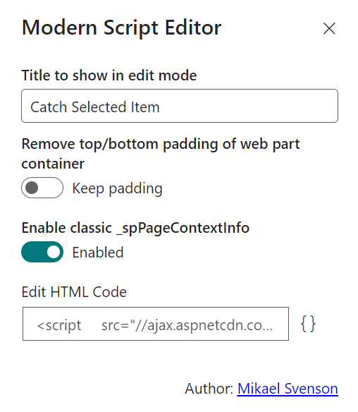

c). M-SEWP:

5. IDEA B School Year New\Edit\Display Form:

a. Display:

b. Form Rules:

i. Hide Display Name on Edit

ii. School Year Locked in Edit

iii. Hide DistrictID in Edit Mode

iv. Hide DistrictCode in Edit

v. Hide LEAN Name in Edit

vi. Hide RecordID in Edit Mode

vii. Hide Attachments in Edit Mode

6. IDEAB LEA Analysis and Plans New\Edit\Display Form:

a. sltLEAID field:

i. Display:

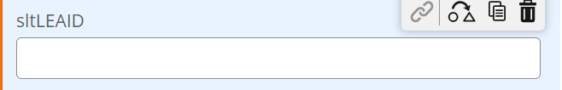

ii. Default Value: getQueryStringParameter("leaid")

b. Form rule:

i. Hide sltLEAID Edit:

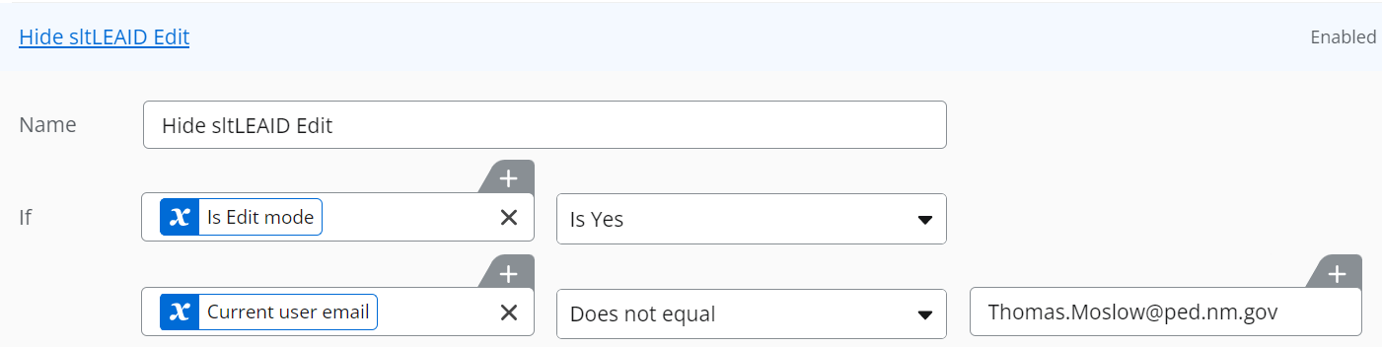

ii. Hide sltLEAID New:

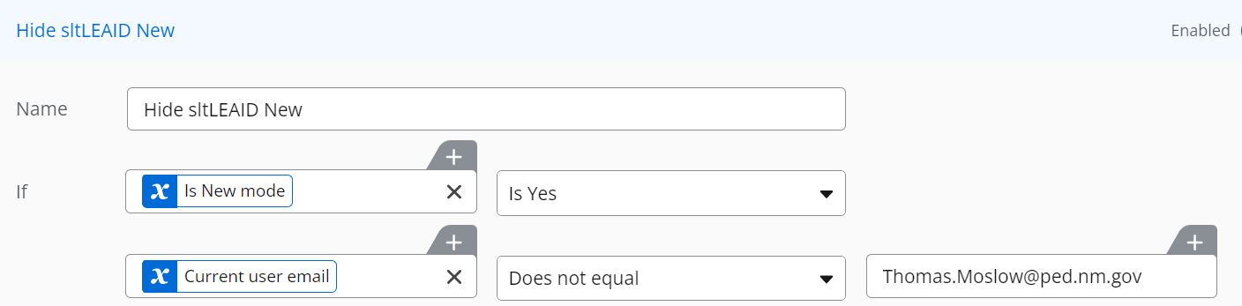

7. IDEA B Basic & Preschool Budgets Objective1 New\Edit\Display Form:

a. sltLEAID field:

i. Display:



ii. Default Value: getQueryStringParameter("leaid")

b. Form rule:

i. Hide sltLEAID Edit:



ii. Hide sltLEAID New:



8. IDEA B Basic & Preschool Budgets Objective2 New\Edit\Display Form:

a. sltLEAID field:

i. Display:



ii. Default Value: getQueryStringParameter("leaid")

b. Form rule:

i. Hide sltLEAID Edit:



ii. Hide sltLEAID New:



9. IDEA B Basic & Preschool Budgets Objective3 New\Edit\Display Form:

a. sltLEAID field:

i. Display:



ii. Default Value: getQueryStringParameter("leaid")

b. Form rule:

i. Hide sltLEAID Edit:



ii. Hide sltLEAID New:



10. IDEA B Basic & Preschool Budgets Objective3 New\Edit\Display Form:

a. sltLEAID field:

i. Display:



ii. Default Value: getQueryStringParameter("leaid")

b. Form rule:

i. Hide sltLEAID Edit:



ii. Hide sltLEAID New:



11. IDEA B Objective 4 CEIS New\Edit\Display Form:

a. sltLEAID field:

i. Display:



ii. Default Value: getQueryStringParameter("leaid")

b. Form rule:

i. Hide sltLEAID Edit:



ii. Hide sltLEAID New:



6. Custom JSON Formatting:

a. JSON Column Formatting – JSON was used to provide custom formatting for several columns:

i. Edit Item:



{

"$schema": "https://developer.microsoft.com/json-schemas/sp/v2/column-formatting.schema.json",

"elmType": "a",

"txtContent": "Edit Item",

"attributes": {

"target": "_blank",

"href": "='/sites/IDEABGrant/Lists/BasicPreSchoolBudgetsObjective1/EditForm.aspx?ID=' + [$ID] + '"

}

}

ii. Click the Link:



{

"$schema": "https://developer.microsoft.com/json-schemas/sp/v2/column-formatting.schema.json",

"elmType": "a",

"txtContent": "Add a New Item",

"attributes": {

"target": "_blank",

"href": "https://nmgov.sharepoint.com/sites/IDEABGrant/Lists/BasicPreSchoolBudgetsObjective1/NewForm.aspx"

},

"style": {

"color": "Navy",

"font-size": "15px",

"max-width": "600px"

}

}

b. JSON List View Formatting – JSON was used to provide custom formatting for several views

i. District items “Card” display style:

{

"$schema": "https://developer.microsoft.com/json-schemas/sp/v2/row-formatting.schema.json",

"hideSelection": true,

"hideColumnHeader": false,

"rowFormatter": {

"elmType": "div",

"attributes": {

"class": "sp-row-card"

},

"children": [

{

"elmType": "div",

"__comment": "DIV 1",

"style": {

"text-align": "left"

},

"children": [

{

"elmType": "div",

"attributes": {

"class": "sp-row-listPadding ms-fontSize-l ms-fontWeight-semibold ms-fontColor-neutralPrimary"

},

"txtContent": "='District: ' + [$District]"

},

{

"elmType": "div",

"attributes": {

"class": "sp-row-listPadding ms-fontSize-l ms-fontWeight-semibold ms-fontColor-neutralPrimary"

},

"txtContent": "='District Code: ' + [$DistrictCode]"

},

{

"elmType": "div",

"attributes": {

"class": "sp-row-listPadding ms-fontSize-l ms-fontWeight-semibold ms-fontColor-neutralPrimary"

},

"txtContent": "='District Type: ' + [$DistrictType]"

},

{

"elmType": "div",

"attributes": {

"class": "sp-row-listPadding ms-fontSize-l ms-fontWeight-semibold ms-fontColor-neutralPrimary"

},

"txtContent": "='Display Name: ' + [$DisplayName]"

}

]

}

]

}

}

ii. Budget Summary items two column display style:

{

"$schema": "https://developer.microsoft.com/json-schemas/sp/v2/row-formatting.schema.json",

"hideSelection": true,

"hideColumnHeader": true,

"rowFormatter": {

"elmType": "div",

"attributes": {

"class": "sp-row-card"

},

"children": [

{

"elmType": "div",

"__comment": "DIV 1",

"style": {

"text-align": "left"

},

"children": [

{

"elmType": "div",

"attributes": {

"class": "sp-row-listPadding"

},

"txtContent": "='District ID: ' + [$ID]"

},

{

"elmType": "div",

"attributes": {

"class": "sp-row-listPadding"

},

"txtContent": "='Preliminary Allocation: ' + [$PreliminaryAllocation]"

},

{

"elmType": "div",

"attributes": {

"class": "sp-row-listPadding"

},

"txtContent": "='Basic Entitlement Fund 24106: ' + [$BasicFunds]"

},

{

"elmType": "div",

"attributes": {

"class": "sp-row-listPadding"

},

"txtContent": "='Total Budgeted 24106: ' + [$TotalBudgeted24106]"

},

{

"elmType": "div",

"attributes": {

"class": "sp-row-listPadding"

},

"txtContent": "='Balance 24106: ' + [$Balance24106]"

},

{

"elmType": "div",

"attributes": {

"class": "sp-row-listPadding"

},

"txtContent": "='Objective 1 - 24106: ' + [$Objective1Basic]"

},

{

"elmType": "div",

"attributes": {

"class": "sp-row-listPadding"

},

"txtContent": "='Objective 2 - 24106: ' + [$Objective2Basic]"

},

{

"elmType": "div",

"attributes": {

"class": "sp-row-listPadding"

},

"txtContent": "='Objective 3 - 24103: ' + [$Objective3Basic]"

},

{

"elmType": "div",

"attributes": {

"class": "sp-row-listPadding"

},

"txtContent": "='Objective 4 - 24106: ' + [$Objective4Basic]"

},

{

"elmType": "div",

"attributes": {

"class": "sp-row-listPadding"

},

"txtContent": "='Objective 6 - 24106: ' + [$Objective6Basic]"

},

{

"elmType": "div",

"attributes": {

"class": "sp-row-listPadding"

},

"txtContent": "='Objective 7 - 24016: ' + [$Objective7Basic]"

}

]

},

{

"elmType": "div",

"__comment": "DIV 2",

"style": {

"flex-grow": "1",

"display": "flex",

"flex-direction": "column",

"flex-wrap": "nowrap",

"align-items": "left",

"max-width": "350px",

"min-width": "200px",

"padding-left": "35px"

},

"children": [

{

"elmType": "div",

"attributes": {

"class": "sp-row-listPadding"

},

"txtContent": "='Projected Carryover: ' + [$ProjectedCarryover]"

},

{

"elmType": "div",

"attributes": {

"class": "sp-row-listPadding"

},

"txtContent": "='Preschool Entitlement Fund 24109: ' + [$PreSchoolFund]"

},

{

"elmType": "div",

"attributes": {

"class": "sp-row-listPadding"

},

"txtContent": "='Total Budgeted 24109: ' + [$TotalBudgeted24109]"

},

{

"elmType": "div",

"attributes": {

"class": "sp-row-listPadding"

},

"txtContent": "='Balance 24109: ' + [$Balance24109]"

},

{

"elmType": "div",

"attributes": {

"class": "sp-row-listPadding"

},

"txtContent": "='Objective 1 - 24109: ' + [$Objective1PreSchool]"

},

{

"elmType": "div",

"attributes": {

"class": "sp-row-listPadding"

},

"txtContent": "='Objective 2 - 24109: ' + [$Objective2PreSchool]"

},

{

"elmType": "div",

"attributes": {

"class": "sp-row-listPadding"

},

"txtContent": "='Objective 3 - 24109: ' + [$Objective3PreSchool]"

},

{

"elmType": "div",

"attributes": {

"class": "sp-row-listPadding"

},

"txtContent": "='Objective 4 - 24109: ' + [$Objective4PreSchool]"

},

{

"elmType": "div",

"attributes": {

"class": "sp-row-listPadding"

},

"txtContent": "='Objective 7 - 24109: ' + [$Objective7PreSchool]"

},

{

"elmType": "div",

"attributes": {

"class": "sp-row-listPadding"

},

"txtContent": "='Objective- 8 Elementary EC: ' + [$Objective8EEC]"

},

{

"elmType": "div",

"attributes": {

"class": "sp-row-listPadding"

},

"txtContent": "='Objective- 8 Secondary EC: ' + [$Objective8SEC]"

}

]

}

]

}

}